1 The Arduino is a micro controller – “open source prototyping platform”

• Devised as an open source product

• Open Source is a philosophy that looks to draw in a community that self supports evolution of the product.

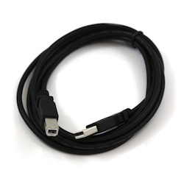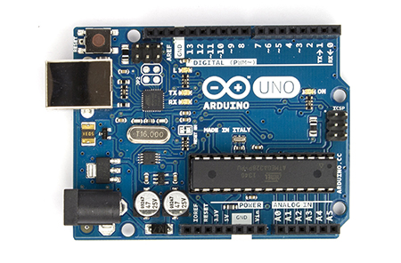

The Basic Board is the UNO Revision 3

We recommended stick non conducting rubber on bottom to prevent slipping and shorting (on a metal surface)

• Bigger boards have

* more Memory
* more inputs

• Power options

* USB – draws 5V from the USB
* Power Jack
* ▪ can run off transformer
* ▪ 9V battery
* ▪ Or a range of other voltage supplies to 12V

• The microprocessor

* Mounting options
  + Surface mount chip – i.e stuck on (SMD)
  + DIP – Dual In-line Package - allows you to slot-in new one if you blow it.

• Input-Output Pins (16 of)

* Digital I/O pins – can define in the code
* PWM – Pulse Width Modulation I/O

• Power Source

* 3.5V
* 5V
* Ground

• Analogue Input 0-5

* Analogue to Digital converter.
* EG: 5V signal - modulating converts to 1-1023

2 Before using your Arduino you need to download software and drivers from the Arduino web site <https://www.arduino.cc/en/Main/Software>.

*Depending on the Arduino model you are using you may need to install additional FTDI or CH340 drivers. Check the Serial interface chip your nano has.*

*The Arduino Nano CH340 drivers for Windows and MacOSX available from our GitHub repository.*

*Additional installation steps are also found here*

<https://www.arduino.cc/en/Guide/Windows#toc4>

3 Now we can connect our Arduino to the PC using the USB lead. The board below in an UNO, depending on your model the board and lead may differ.

4 In Windows launch “Device Manager”. Your device should show up under the COM ports



5 Now in the Arduino IDE we can select the correct board and serial port to which your Arduino is attached, your port should be visible under the Tools | Port menu.



6 And the right port:



***Under Windows this will be a COM port, under Mac OSX this will be a /dev/usb….port***

7 Now open an example program in the IDE, then click the Upload icon to load the program to the Arduino. If the drivers are installed correctly and the correct port has been selected, you will see the RX and TX lights on the Arduino flicker and a confirmation message that the upload completed. A few seconds later you should see your program in action!



For more information and additional lessons try the following useful links:

<https://www.arduino.cc/en/Guide/Windows#toc4>

<http://kiguino.moos.io/2014/12/31/how-to-use-arduino-nano-mini-pro-with-CH340G-on-mac-osx-yosemite.html>

<https://www.youtube.com/watch?v=kLd_JyvKV4Y>